BS Agency Pay
for


Software to simplify paying temporary staff and billing clients

Key in the timesheets once - out come payslips and invoices

Complete Holiday Pay facilities and Working Time records

Clear detailed documents - minimise questions from staff and clients

Easy to use - flexible enough to be useful

This revision – November 2000 (Version 5)

1. Contents
1 1. Contents 2
1.2. New in version 4 4
1.3. New in version 5 4
1.4. Terms of Licence 5
2 System Requirements 5
2. Getting Started 6
2.1 Installation 6
2.2. Document Design - Payslips 7
2.3. Document Design - Invoices 8
2.4. Payroll Groups 9
2.5. Charge and Pay Rates - Using Rate Cards or not? 11
2.6. Initialising BS Agency Pay 15
2.7. Initialise Feature 17
3. Using BS Agency Pay 18
3.1. Weekly Procedure 18
3.2. BS Agency Pay - Main Menu 19
3.3. Sales ledger - Sales Codes 20
3.4. BS Agency Pay – Rate Cards 21
3.5. BS Agency Pay - Client / Sales Ledger Processing 31
3.6. BS Agency Pay Client / Sales Ledger Processing - rateS 32
3.7. BS Agency Pay Client /Sales ledger - Processing - Timesheets 34
3.8. Payroll processing - Rates 35
3.9. Payroll - Payments 36
3.10. Payroll - Deductions 36
3.11. Employee Profile 37
3.12. BS Agency Pay Employee - Payroll Processing Timesheets 38
3.13. Timesheet - Holiday Pay 43
3.13. Timesheets 44
3.14. BS Agency Pay – Bank Holidays 45
3.15. BS Agency Pay - Calculate 46
3.16. Invoice Printing 48
3.17. Working Hours & Holiday Pay Enquiry 50
3.18. Working Time Regulations – Definitions and Options 52
3.19. Payroll Update 58
3.20. AP History 59
3.21. AP Reports 60
4. Training and Customisation 62
4.1. BS Agency Pay - Demonstration data 62
4.2 Customisation 63
4.3. Invoice and Payslip Design 65
4.4 BS Agency Pay - Import System 69

New in version 4

- Available for Opera for Windows
- Calculation Interlock
- Multiple options for Holiday Pay calculations
- Monthly paid timetable as parameter
- AP Menu includes Opera Payroll options within Utilities
- Initialising program to aid start-up
- Input of pre-AP timesheet data
- Simplified update at end of period

New in version 5

- Foreign Currency – set the rates and currencies on the rate card
- Option to change the rates during timesheet entry
- Option to make the charge hours different from the pay hours
- Rate card can be ‘don’t charge’ or ‘don’t pay’
- Rate card can be restricted to a temp as well as a client
- Rate card has 2 user defined fields and optional start and finish dates
- Enter timesheets by selecting a ratecard, which automatically selects client, temp, ratecard and (if only one) the skill.
- Import – Clients, Employees, Timesheets
- P45 print – with details as at date of last payment.
(page printer – use Inland Revenue P45 Laser Sheet stationery)
- Skills (free text) can have a skill code attached to allow analysis
- Option tp ptint and/or edit the settings file (BSGLOAD)

1.4. Terms of Licence

BS Computers licences you to use BS Agency Pay on the designated Opera system to assist in the calculation and printing of payslips, invoices and other documents. We will take reasonable steps to discover and remedy any faults in the software and in this manual. We do not give any warranty that BS Agency Pay or this manual are error free and that the software is entirely suitable for any use which you make of it. BS Computers and our resellers will take reasonable steps to repair any defects which we find or are brought to our attention and will distribute the updated software to users who have appropriate annual licence contracts in place. To ensure that we are free to continuously refine and improve the software any such remedies will be implemented as part of the latest release and will not be available retrospectively. This manual is distributed on the release media of BS Agency Pay and use of the software will be taken as acceptance of these terms.

System Requirements

BS Agency Pay requires a reliable installation of Pegasus Opera as its working environment.

Text printers should be Epson compatible and Windows printers should be HP Laserjet compatible.

To support BS Agency Pay you should have a good working knowledge of Pegasus Opera, including printer set up and customisation of printed documents.

Getting Started

Installation

Installation consists of running one or two Installation files. These file will have your BS Agency Pay Licence number plus either DOS or WIN as the file name. Simply double click on each file and follow the on screen instructions.

After installation you must run Update Data Structures from within the Opera, System menu before BS Agency Pay will be visible.

BS Agency Pay updates the Opera directories in the following way:

\OPERA(W)
programs
REPORTS
report programs
SYSTEM
menu and dbfs

All programs, reports, menu and dbfs are identified as BSG*.* ( you also get a copy of BSBROWSE which is identified as BS1*.*). If you have other third party software in use in your Opera system you may need to edit the issue files to avoid conflicts - please phone for advice if this is the case.

Before installation you might choose to delete any add-in files from \system (???dbfs.*, ???menu.* and ???help.* except SEQ*.*) and to reinstall Opera which has the effect of removing all 3rd party products from the menu and data dictionaries. If you are upgrading from BS Agency Pay 1 - please delete all bs9*.* from your opera system before installing BS Agency Pay 2 or 3.

2.2. Document Design - Payslips

We provide report designs for invoices and payslips to suit Epson compatible or Laserjet compatible printers. We can supply continuous payslips or you can use 11” or A4 plain paper. Reports are designed for 11” continuous stationery. All reports can be customised through normal Opera techniques.

Opera prints payslips using SQWGRP1(.*). You should replace these with either BSGPSLP.* (for continuous 11” stationery) or BSGLPSLP.* (for sheet fed desk/laser jet). You can of course rename the payslip design to make it specific to a company, X_WGRP1.*, as usual in Opera.

e.g.. You should:- copy BSGPSLP.* A_WGRP1.*
or copy BSGLPSLP.* A_WGRP1.*

2.3. Document Design - Invoices

BS Agency Pay prints invoices using BSGINVCE.*.

You can install this as X_GINVCE

We supply the following draft invoice document designs:-

BSGINVCE.* - Pegasus invoice stationery (PEG020)
(Epson p-esc compatible)
A4GINVCE.* - A4 continuous stationery (Epson p-esc compatible)
BSGINVCL.* - A4 cut sheet (Laserjet compatible)

You should copy the appropriate one of these three to X_GINVCE.*

Each sales invoice contains a print of the timesheet details. The layout of this printout may be customised by suitably skilled staff. Some knowledge of FoxPro syntax is required and trained Opera support staff should be able to do all aspects of document design and configuration. A section of this manual gives details of how to change the layout of the timesheet as it is printed on an invoice. (See Section 4).

2.4. Payroll Groups

In BS Agency Pay, in any one week we have to recognise 4 types of employee

- an employee who has left and will not be processed again
- an employee who has not left but has no timesheet and does not want a P45
- an employee who has not left, has no timesheet but needs payslip for holiday pay, tax refund or adjustment
- an employee who has not left, has a timesheet and may have other payslip entries

BS Agency Pay handles these possibilities by using four Opera payroll groups (or eight if you have both weekly and monthly employees).

The following paragraphs describe how we cope with all the possibilities which can arise.

- Employees who have left, had their P45 and will not require a payslip again - Group Q (or Group R)
- Employees with no timesheet but not asking for P45 and not requiring a payslip this week (or month) (i.e. not a payslip for tax refund only)
In Opera - Group Z (or Group Y)
- Employees with no timesheet this week (or month) but needing a payslip for holiday pay, adjustments, tax refunds etc. (possibly leaving at the end of this week (or month) and requiring a P45)
In Opera - Group A (or Group B)
- Employees with timesheets being paid this week (or month) - (might be leaving at the end of this week (or month) and want a P45)
In Opera - Group W (or Group M)

The existence of four (eight) groups in Opera allows us to automate the transitions which can take place - i.e.

Payroll Processing Timesheets

- Entry of a timesheet with a week number of the current week or earlier will cause the employee to move to Group W (or Group M)

- Deleting all the timesheets with a week number of the current week or earlier will cause the employee to move to Group Z (or Group Y) or if they have holiday PAYE etc. to group A (or B)

BS Agency Pay Calculate

This will examine all employees in Groups A,B,M,W,Y and Z, and:-

if there is a timesheet with a week number of this week or less
move the employee to Group W(M)
(type is 1)
else if there is a (manual) payment in A04-A99
move the employee to Group A(B)
(type is 3)
else if the employee is flagged as a leaver
move the employee to Group Q(or R)
(type is 4)
else move the employee to Group Z(Y)
(type is 2)

Under this scheme we suggest that Groups Z (and Y) should not be calculated. If however your agency’s practice is to issue tax refund payslips to inactive employees then you can calculate Group Z (and Y). Any exceptions, such as an employee with no timesheet but asking for a tax refund or requiring some kind of adjustment may need operator assistance to transfer the employee to Group A or B though this should happen automatically in Agency Pay Calculate.

Groups Q (and R) are parking groups for completed employees who have had a P45 and must be kept until year end and should never be calculated. If someone leaves then returns, you can use Agency Pay’s Kopy option to make a new payroll record by copying the old record to a new reference.

The Initialiser program will create all required groups and invite you to review their options.

2.5. Charge and Pay Rates - Using Rate Cards or not?

A rate card is a set of up to 20 skill descriptions with charge and pay rates

e.g.

Skill | Charge Rate | Pay Rate
Secretary | 10.00 | 7.50
Typist | 8.00 | 6.50
Junior | 6.00 | 4.50
Watchman | 5.00 | 4.00

You can have as many rate cards as you want. Each has a reference and title to identify it. A rate card can be restricted for use to one delivery point or one client, or it can be left open for use by any delivery point. When you enter a timesheet you can opt to use a rate card or not. If you use a rate card the client is charged at the rates on the rate card and the employee is paid at the rates on the rate card.

Instead of using rate cards you can use the following procedure

- in the Rate Cards option, on the default Rate Card, specify up to 20 skills which your employees supply to your clients.
- on each delivery point you specify the rate the client will pay for these skills
- on each employee you specify the rate that employee will be paid for these skills

This decision reflects the two obvious ways of pricing a timesheet. The following page details these two methods. (We discard another way which is to type the rates in when you enter the timesheet)

Method 1

Create a number of rate cards, each having its own set of skills and charge and pay rates. This allows more skills and allows matching charge and pay rates to be created - if the client pays less, the employee can get less pay. The number of rate cards is effectively unlimited. The main advantage is that you can change rates very easily - just change the rate card and all subsequent timesheets will be priced at the new rates. You can have a rate card for standard customers, one with lower mark-ups for larger customers; you can have a special rate card for a profession or trade which needs different skills, etc. etc.

The obvious disadvantage is that you can’t fix pay rates for each employee. (Unless you create a specific rate card for that employee. In general, a rate card for a client or delivery point is practical, a rate card for each employee is possible but a rate card for every permutation of employee/delivery point would probably be impractical)

Method 2

For each delivery point, for each of the 20 system default skills you set a rate for the client to be charged and for each employee, you set a rate for each skill he/she is to be paid for. This means that for a given skill, whichever employee does the work, the charge rate is the same and wherever an employee works at that skill he/she is paid the same irrespective of client. Tailoring the rates for each delivery point and employee is possible. This can result in a very easy to use system where the default rates are set and used on every client or employee, but it might be too inflexible and the margins can vary. A limitation is the need for a set list of skills which for convenience is limited to the number of lines which can be seen on a screen.

BS Agency Pay allows either or both of these methods to be used. Any one timesheet will use one of these methods.

If you want to ‘lock’ the charge rate to the pay rate for a given skill, so as to preserve a predetermined margin, you should use a rate card. If you have to pay each employee at his personal rate and charge each client at their personal rate you can put rates on the employee and rates on the delivery point but then your margin will vary according to which employee does the work. (BS Agency Pay has margin reports to help you monitor this situation.)

We think that rate cards will be the normal method as it can cope with any eventuality up to the point where you create a rate card for every single contract. (BS Agency Pay provides a facility to copy existing rate cards.)

To help you choose your preferred method try this analysis:

If two temps go to the same client with the same job specification -

Does the client always pay the same rate for both temps? Yes/No

Do the two temps always get paid at the same rate? Yes/No

If Yes and Yes - you suit the use of rate cards - one rate card will do everything for that client unless you need more than 20 skills when you can make continuation rate cards. Other clients or delivery points may need their own rate cards.

If Yes and No - you need not use rate cards unless you need more than 20 skill descriptions. Each delivery point will have its charge rates set and each employee will have their own pay rates. You are limited to 20 skill descriptions for all your employees.

If No and Yes - you need a rate card for each temp (or grade of temp); the charge rates will be different but the pay rates will be the same on each rate card.

If No and No - you need a rate card for each ‘contract’. The charge rates and pay rates will be specific the the contract for that temp at that delivery point. (you will be best served by creating a delivery point and a rate card using the ‘contract number’ as the reference for both.

When entering a timesheet

- if you specify a rate card, then the rates on that rate card will be used to price the timesheet - for both the charges and the payments.

- if you don't specify a rate card then the rates will be taken from the delivery point and the employee.

To speed up creation of new delivery points’ and employees’ rates, there is a set of Global Defaults. The Global Defaults are:

- a short cut to setting employee and delivery point rates
- for naming the 20 skills available when not using a rate card
We fill the default rate card with the values used in our demo data but you will have to review everything - after you have created suitable sales codes (and supply codes) and payslip payments and deductions.

2.6. Initialising BS Agency Pay

After setting up a company in Opera you will need to achieve the following, broadly in this order The Initialiser program will create almost all of this or fill any critical gaps – we suggest you run it first then .
:-

- In Payroll - Set up Groups - W & M for active employees
- Z & Y for inactive employees
- Q & R for leavers
- A & B for adjustments (non timesheet)

- Set up payments for Pay, Mileage and Expenses, these must
be the first three payment types created in that order.
- Set up a payment for Holiday Pay and a deduction for Holiday
Accrual.
- Set up an Employee profile with non-zero holidays entitlement
(and one with zero holiday entitlement if you have employees
who are exempt from WTR).
- Create Sales Codes

- In BS Agency Pay Rate Cards enter your 20 skill descriptions on the default Rate Card (not necessary if you use rate cards)
- In BS Agency Pay Utilities enter your settings, defaults, rate cards etc.
- In BS Agency Pay Client (or Sales Ledger Processing) - set up an account for each client
- In BS Agency Pay Client (or Sales Ledger Processing) - set up an account for each delivery point.
- In BS Agency Pay Client - set up Rates for each delivery point. (not necessary if you use rate cards)
- In Payroll - set up payments for pay, mileage and expenses - these must be the first three payment types in that order - set up a payment for Holiday Pay and deduction for Holiday Accrual. Set up an Employee profile.
- In BS Agency Pay - create a record for each Employee (in group W or M) and set up Rates for each employee (not necessary if you use rate cards)
- If you have sub contractors create Supply Codes in the Purchase ledger
- If you have multi currency or EC VAT, check that you have created all required currencies and VAT Codes.
- In BS Agency Pay Sub Contractors (NOT Purchase Ledger) create an account for each sub contractor and set up Rates and supply codes for him (not necessary if you use rate cards)
- Copy the appropriate report formats to suit your invoice and payslip stationery
- Then you can enter timesheets and print invoices, payslips etc.

Initialise Feature

This is an option within the Utilities Menu to help with the set up of BS Agency Pay.

It may be run repeatedly and will not overwrite anything you have previously done. You could run it before doing anything and it will prompt for missing steps. You can then supply these and run it again etc.

If you have a payroll running you should make sure you have enabled groups then run Initialise. If you have a linked Nominal Ledger it should be set up prior to running the Initialise feature.

The initialiser carries out the following steps in the order shown

- Check if payments and deductions exist and create initial set if not.
- Check if employee profiles exist and create initial set if not.
- Check if sales codes exist and create initial set if not.
- Check if supply codes exist and create initial set if not.
- Check if bank data exist and create initial set if not.
- Check if payroll options have been set up for the default group - if not - tell you and stop.
- Check for existence of, and if necessary create any of, the groups ABMWQRYZ
- Provide access to all groups for you to edit them
- Check if default rate card present if not run the rate card program
- Check if any employees - if not - stop.
- Check employees for duplication - and report - if any - stop for you to transfer them.
- Initialise BSWEEK from the settings in BSGLOAD
- Offer to move all employees in existing groups to BS Agency Pay groups, creating bswnam records in the process

3. Using BS Agency Pay

3.1. Weekly Procedure

- Create any new delivery points; sub contractors, employees and rate cards

- Change code numbers etc.

- Enter timesheets

- Enter any other pay elements e.g. holiday pay or deductions

- Calculate (BS Agency Pay)

- Print reports - margin reports, timesheet lists etc.

repeat any of the above until you are satisfied

- Print payslips, standard payroll reports, transmit BACS etc.

- Print sub contractors self billing invoices, authorise payments, transmit BACS etc. as appropriate

- Print Sales Invoices

- End of Period Update

More details on the BS Agency Pay aspects of these tasks follows over the page.

3.2. BS Agency Pay - Main Menu

All the facilities of BS Agency Pay are available within the main menu shown below. Regular Opera features such as sales codes, supply codes, etc, are to be found in their usual places within Opera. All the Payroll Utilities options are available from within BS Agency Pay’s Utilities.

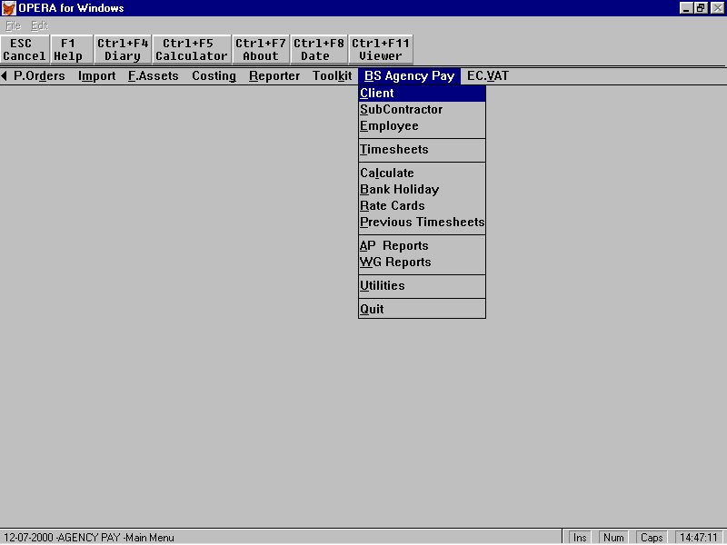

The BS Agency Pay menu should be used in preference to Opera’s menu for anything to do with BS Agency Pay.

Sub Contractors should be created in this menu not in Purchase Ledger to ensure that BS Agency Pay can immediately add them to its master file of personnel. (If added in Purchase Ledger, BS Agency Pay will eventually process them correctly after rates or a timesheet have been entered)

All Holiday transactions should be entered through this menu - Opera’s holiday arrangements are completely irrelevant to BS Agency Pay.

3.3. Sales ledger - Sales Codes

You need to create sales codes for:-

- Pay recharged,
- Profit on pay,
- E’Er NI charged out,
- Mileage recharged,
- Mileage profit ,
- Expenses recharged

each with its Nominal code and vat code.

You might get away with less than 6 codes but you probably need more. If some clients justify different VAT treatment you might need a set for both standard and for zero rates. If you want to analyse sales to multiple nominal codes you will need multiple sets.

e.g. for Pay Recharged - North/South - VAT at standard(1)/Zero you might create

PRN1 and PRNZ
PRS1 and PRSZ

similarly for Pay Profit

PPN1 and PPNZ
PPS1 and PPSZ

etc.

If you want to use cost centres to provide analysis reports for your branches you should enable the Opera facility to use the delivery point analysis code.

3.4. BS Agency Pay – Rate Cards

Here you must set up some essential values and you can also set up the values you might use for most of your accounts and employees. Remember - these are defaults and you can set different values for every client and employee if you wish.

At the first time of using this option the system will proceed to the first set of data which become the Global defaults. On subsequent occasions, you will be able to choose from a list of rate cards, the first of which is the Global Defaults

Here is the first screen for the default rate card (you fill in the bold bits):-
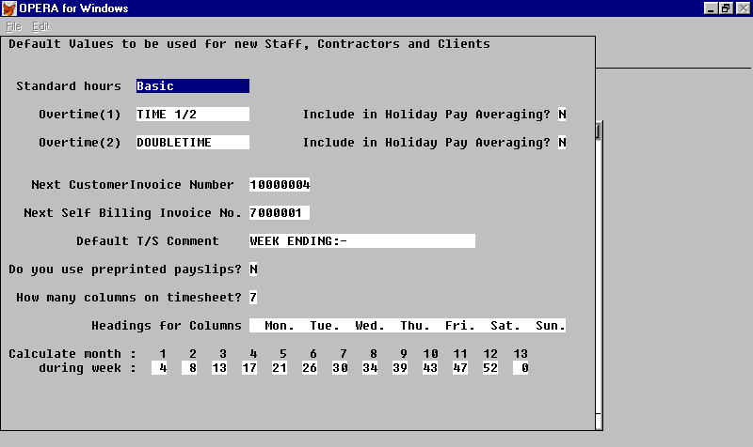

You should give a name to up to three bands of payment rate (at least one). The band names can be specific as above or generic e.g. rate1, rate2, rate3 which allow any mix of hourly, daily, or per event rates. These bands are used on all client and employee defaults.

You may set the number of the first client invoice to be produced (or change it); similarly the number of the next self billing invoice.

If you use our pre-printed payslip stationery, the system will print a cancellation of the payslip part of any continuation pages and you must tell AP that you are using pre-printed payslips (Y). The alternative (N) is to print payslips on a laser printer on plain paper or dot matrix using continuous plain paper. Our standard design uses continuous plain paper.

When you use this screen on a rate card rather than the global defaults you will find fields for rate card description and account restriction which only appear on rate cards in place of the invoice number and default timesheet comment. The description is simply an expansion of the rate card’s reference number. The restriction is an account number which has exclusive use of this rate card. The account can be a delivery point or a client as you wish.

Here is an example of the first screen for a non-default ratecard. It shows the use of the dates, the user fields, foreign currency and the facility to switch charge and pay on or off.

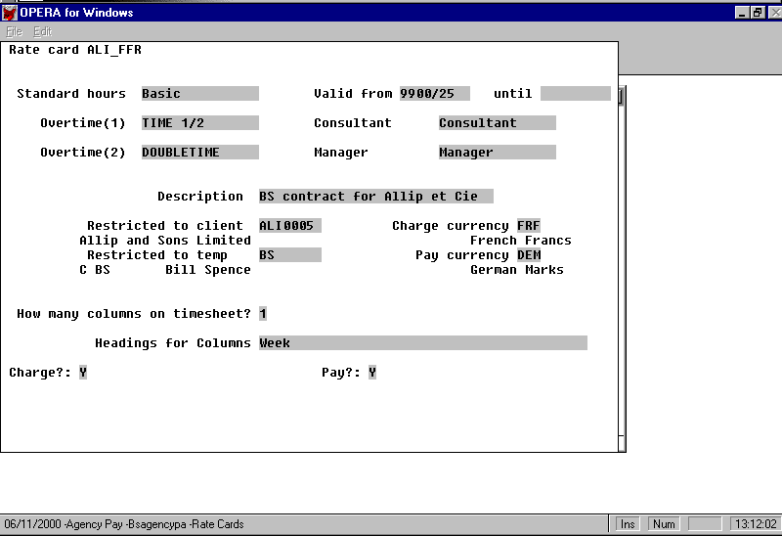

A rate card can be restricted for use on just one delivery point or any delivery point for a client. It will not then be available for timesheets for any other delivery point or client respectively. This could prevent special rates being used on general clients.

The ratecard may also be restricted to one temp (employee or contractor). When you do this, you can enter a timesheet by selecting the ratecard which will the automatically select the temp and delivery point.

Here is the first part of the second screen:-

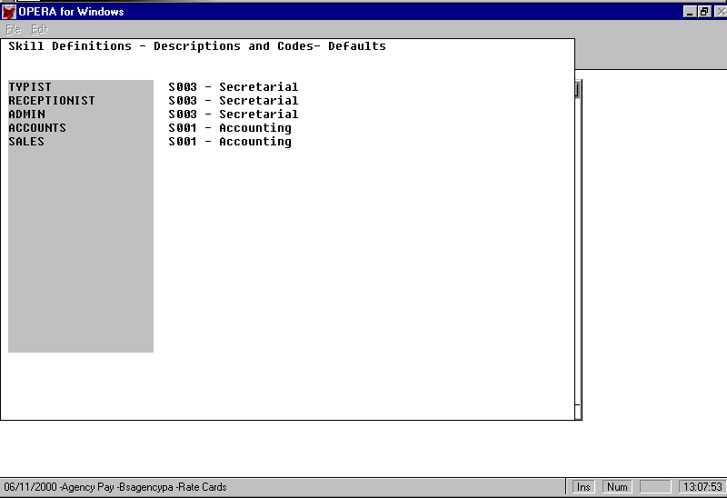

Here you define the job descriptions to be used on timesheets, invoices and payslips when you are not using a rate card. If you use rate cards, each rate card has its own list of skills which are free text to suit you and your client. Each skill can (optionally have a skill code attached for use in analysis.

Here is the second part of the second screen:-

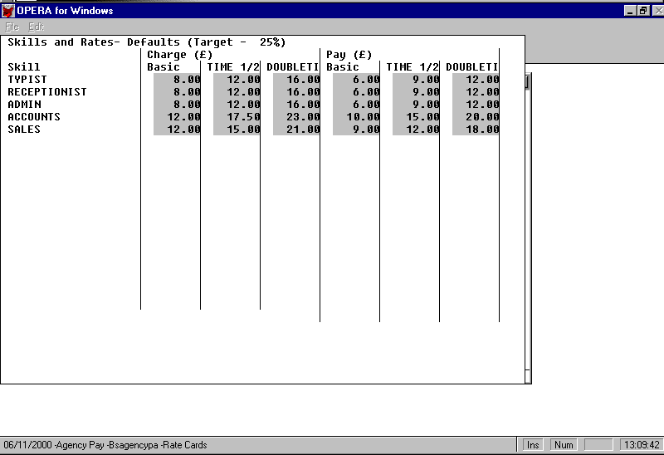
These are the default charge and pay rates. In the case of the Global defaults they will be used when you create a new delivery point or employee. You can then change them to specific values if you need to.

In the case of a rate card these rates are fixed at this time and are used to ‘price’ a timesheet.

You can set up a target margin (we have shown 25%). AP will then monitor charge rates against pay rates and highlight any which fall below the target

If you have created a foreign currency rate card there is a facility to view it in its (current) sterling equivalents; again the margin will be calculated and any low margins will be highlighted.
Here is the third screen

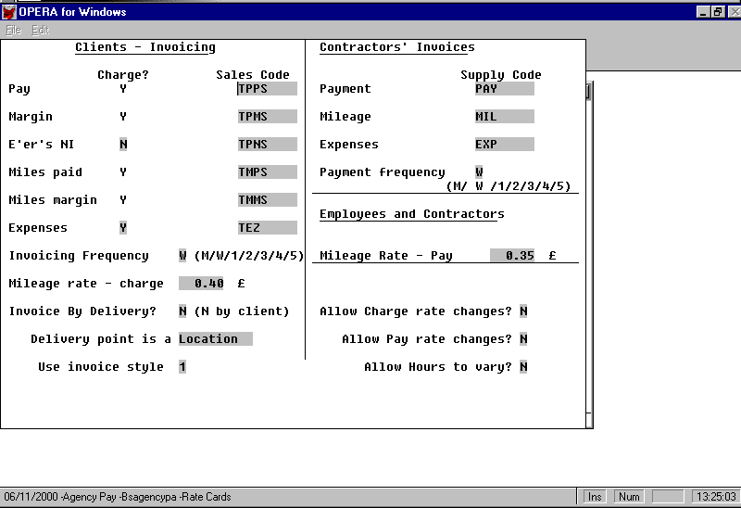

The sales and supply codes are self evident and must already exist in the relevant ledgers.

You have the option to add the employers NI to your charge rate. Some clients do not like to pay VAT on the employers NI. In this case, the sales code will show a zero rate and the option will be Y. The charge rate will presumably be slightly less than otherwise. Remember this is the default setting so enter your most frequently used options here. Each client may have their own appropriate setting which will overwrite the default.

Expenses paid to employees may be recharged to clients (Y) or not (N). Enter X if you don’t want expenses on timesheets.

Clients (i.e. statement accounts) may require to be invoiced in either (or a mix) of the following methods:

- one invoice to the client for all work done, (listing the delivery points and employees; one invoice uses less paper but the client can dispute it all at once!)
- one invoice to each delivery point, (listing all employees who worked on that delivery point; produces more invoices but the client can’t dispute them all so easily)

In invoicing frequency you should set the most frequent requirement e.g. W for weekly. (See Invoice Printing below)

If you enter zero as the mileage charge and pay rates the mileage will not appear when you enter a timesheet using this rate card.

The system can invoice on a Weekly, Monthly or one of 5 (1-5) other frequencies which you can choose. Suppose you need a fortnightly invoice - you could use 2; then you would select type 2 invoices to be printed every even week, (perhaps with type 1 in the odd weeks?). Type 4 could be 4 weekly - you select every fourth week to print the 4 weekly clients’ invoices etc.

Each delivery address will have a description.

For instance, if you are predominantly a nursing agency it will probably be patient, home or hospital.

If you are a general agency it might be a booking, contract or job.

Again remember that this is the default - every delivery point can be tailored to suit the client’s understanding.

You can choose either of the two layouts of timesheet to be printed on your invoices - choose the one you will use most often for the default setting. (1 is a detailed description of the timesheet and 2 is a brief description; but you can modify either or both of these designs. Each rate card may have its own setting but we suggest you don’t mix layouts on the same invoice)

You can give or withhold permission for the operator to override the charge or pay rates when entering any timesheet against this ratecard.
The final screen of the default rate card relates to holiday pay and working time regulations.

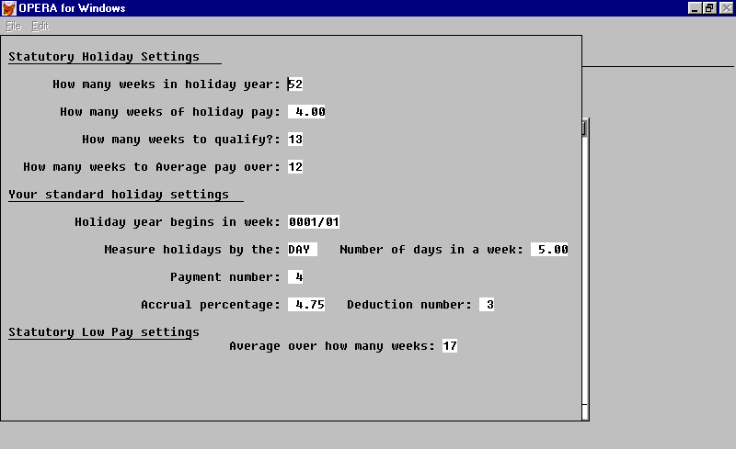

The number of weeks in the holiday year will normally be 52. The number of weeks of holiday is set by the regulations to 3 until 23rd November 1999 then 4 so you may need to apportion according your holiday year. (BS Agency Pay does not allow for individuals to have their own holiday year.) The regulations set a qualifying period of employment before a worker is entitled to holiday pay and a number of weeks over which a worker’s pay is to be averaged (currently 13 weeks and 12 weeks respectively).

You must enter the first week of your holiday year (and update this annually) - express this as a payroll week number. You should enter your preferred unit of measure and the number of these in a week - this will set the unit of entry of holidays such as bank holidays - e.g. DAYS and 5, or HOUR and 37.5.

BS Agency Pay will tell Opera to accrue a sum each week based on the percentage you enter here and on each employees pay (Pay element A01). You should allow for the possibility that a proportion of workers will not reach the qualifying time. Suppose that the holiday entitlement is 4 weeks in 52 and one third of your employees will leave half way through the qualification period for holidays.

Employees who stay a whole holiday year will on average take 4/52 of a week of holiday in each week which means you need to save up 7.7 % of their wages to pay them holiday pay. But if only two thirds of the total employees stay long enough to take holidays you need accrue only 5.12% from all employees. You can work out your own percentage along these lines.

You need to tell BS Agency Pay which payment element you have set up for holiday pay and which for the accrual. In Opera you can set up links to the Nominal ledger in the usual way. Note that since the accrual percentage is an approximation and is not created for each employee it is not meaningful to compare an employee’s holiday pay against the accrual made against his earnings. You can compare the company’s total amount of holiday pay and the total accrued on a year to date and possibly branch (cost centre) basis. Opera’s Nominal posting facility will allow you to allocate the cost of holiday pay against the accrued amount.

The final entry on this screen is a statutory figure - the number of weeks over which employees’ hours are checked for maximum hours per week and minimum pay rates. This is used in the BS Agency Pay Employee - Averages enquiry.

There are additional options for Holiday Pay processing. These are presumed to be based on policy decisions made when the system is installed so they are held on BSGLOAD and are not meant to be changed after they are set up.

They are

L_INCLHOL do (not) include holiday pay and weeks in averaging

L_FOREST[1] the qualifying period must (need not) be N consecutive weeks with a timesheet.

L_FOREST[2] each timesheet will (not) have the number of days worked entered by the operator

L_FOREST[5] (if not l_forest[2]) Every employee’s standard working week will be taken from his record (if not then the agency standard will be used)

See Section 4 for listing and changing these settings.

After creating the Global defaults you can then create further rate cards. The method is very similar to creating the defaults. You can

- add a new rate card by pressing F5
- copy an existing rate card as the basis for a new one by moving down (up) to it and pressing F4 .
- edit an existing rate card (including the standard defaults) by moving down (up) to it and pressing F6 .

When you add a new rate card you will be asked for a reference for it. Thereafter the screens are very similar to above with slight differences on the first screen where you may restrict a rate card to a specific delivery point (or client).

3.5. BS Agency Pay - Client / Sales Ledger Processing

Every client will have an account which you create in the standard Opera style. Set up all Options, Terms, Delivery etc. as if you were going to use Opera invoicing/SOP. It is important to set up the analysis details completely before invoicing as any mis-analysis of an invoice cannot easily be changed (as is also true for Opera invoicing).

All timesheet work is logged against a delivery point. Every client therefore must have at least one delivery account created with the client account as its statement account. This too is standard Opera - Sales / Processing / Add.

You can use the delivery point for any suitable purpose. For instance:

A nursing agency will have a Health Board as a client plus a delivery point for each home/hospital, or even each patient.

An accounting agency might want a separate delivery point for every single booking or each client department.

A catering agency might have each department head in each hotel as a delivery point.

The client will have asked to be invoiced by the patient, home, hospital, job etc. so you should create delivery points to suit each client’s request. If the client suggests one big invoice you can tell BS Agency Pay to invoice by client (instead of by delivery point). Remember - it might not suit you to send out very long invoices where payment might be held up because of a dispute on one timesheet.

3.6. BS Agency Pay Client / Sales Ledger Processing - rateS

If you plan to use rate cards you do not need to set rates for each delivery point.

If when entering a timesheet you do not specify a rate card, BS Agency Pay will look for rates on the delivery point - if you have not entered rates BS Agency Pay will copy the default rates. You probably will not want to use the global rates, sales codes etc. on every delivery point, so we recommend that you always do enter rates, possibly zeroing the rates on some skills to prevent their use.

When you first use this facility, the default values will be copied in, but you can then customise them to suit this client and delivery point.

The first group of entries is the charge rates:-

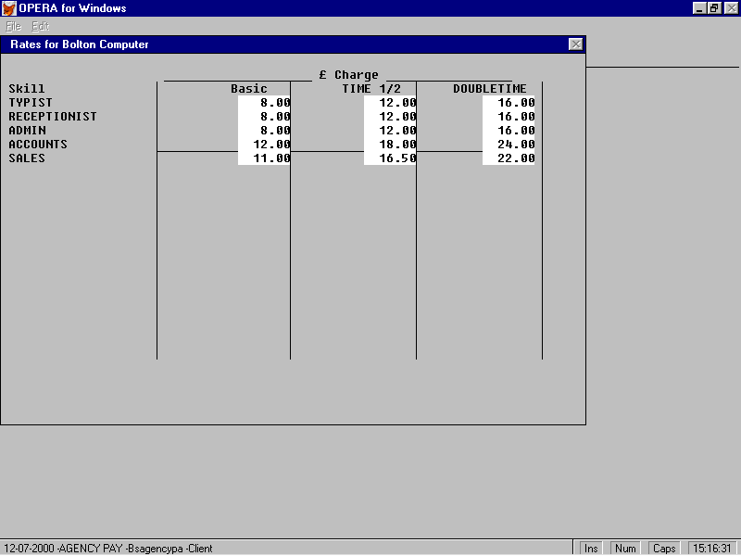

These are the rates that will be charged for any employee who does work at this delivery point. (Unless a rate card is used for the timesheet.)

A zero rate implies that the skill or grade is not relevant and the system will not accept input hours from a timesheet.

Here is the second group of entries on delivery point rates:-

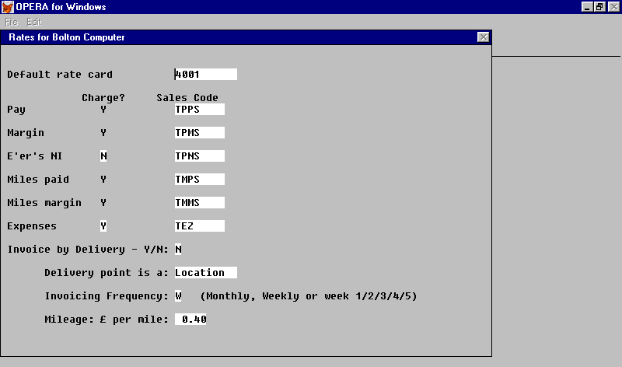

These options were described in the defaults section previously. The rate card field allows you to specify the rate card you will probably use for this delivery point. When you enter a timesheet you can choose a different rate card if this is not the one you want.

3.7. BS Agency Pay Client /Sales ledger - Processing - Timesheets

This option is similar to Payroll - Processing - Timesheets with the following added feature.

After adding a new timesheet for the chosen delivery point the system repeatedly asks for another employee/subcontractor reference and will automatically repeat the rate card selection and hours etc. This allows the rapid entry of many employees who worked the same hours on the same job - e.g. a number of waiters at a function. The delivery point will probably have its invoice style set to the brief version so that the invoice will have as many people shown as possible.

3.8. Payroll processing - Rates

If you plan to use rate cards you don’t need to put rates on each employee.

The first group of entries are the rates this employee will be paid at, wherever he/she works - (if you don’t enter rates for this employee you will always have to use a rate card for his/her timesheets).

If the employee doesn’t have one of the skills - change the rates to zero and no hours will be allowed on the timesheet for that skill.

After these rates you can enter the mileage rate which this employee is to be paid.

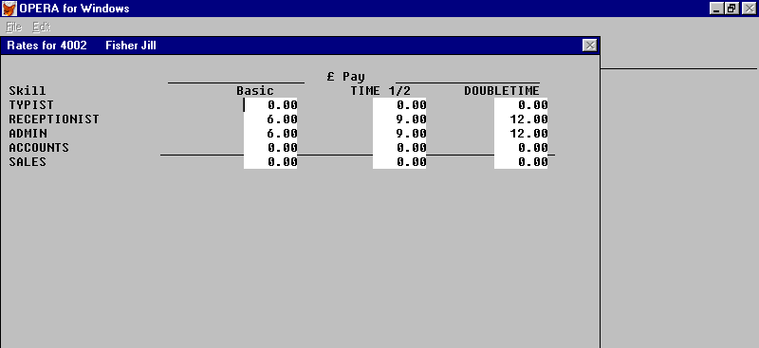

This screen may also have a space for entry of the number of days in the employee’s standard week. If this employee normally works a three day week you can say so here and his holiday entitlement will be three fifths of the normal (The company standard (5?) is set in the default rate card. This saves entering the number of days on every rate card. If you prefer not to choose a standard number of days for your company or employees then you should use the ‘enter days on timesheet’ method.

3.9. Payroll - Payments

The employee’s timesheets will be calculated and reduced to three payable amounts - Pay, Mileage and Expenses.

You must create three payment types - as follows

A01 | for pay | taxable, pensionable, NI able etc.
A02 | for mileage | non holiday, non taxable?, non pensionable? non NI able?
A03 | for expenses | non holiday, non taxable?, non pensionable? non NIable?

You may choose the descriptions yourself to suit your payslip requirements so long as the wording indicates pay, mileage and expenses.

You should also create a payment type for Holiday Pay and enter its number in the default rate card’s WTR section.

3.10. Payroll - Deductions

You should create a deduction for Holiday pay accruals (Type H) and enter its number in the default rate card’s WTR section.. This will calculate an accrual percentage of the A01 Pay. It will not deduct it from the employee but will post it to the Nominal ledger if you have linked Payroll to Nominal in Opera Company Profiles. This is an approximation of your companiy’s future liabliliy for holiday pay. It cannot be exact since future holiday pay rates and amounts are not known. At year end you will have a shortfall or surplus in this account which will guide you in setting the accrual percentage for the following year.

3.11. Employee Profile

You will need an employee profile which offers payments 01, 02, 03 plus your holiday pay payment and the deduction for holiday pay accrual and any other payments or deductions you might need.

If the holiday entitlement in your employee profile is set to zero the BS Agency Pay will calculate zero holiday entitlement. You may therefore choose to create more than one profile to cater for employees who are entitled to holiday pay and those who are not.

3.12. BS Agency Pay Employee - Payroll Processing Timesheets

If there are already timesheets entered for the selected employee, you are asked to select the one you want to edit from a browse list as follows. (If there are none, the system skips to the first screen of timesheet entry.) Timesheets which have been invoiced (and paid) are at the foot of the lists. Typically, the one current timesheet is at the top - you can move up or down to a particular timesheet or take the following actions.

- Press F5 to add a new timesheet.
- press F6 to edit the one you have selected (provided it has not been invoiced)
- Press F7 to enter holidays being taken this week.

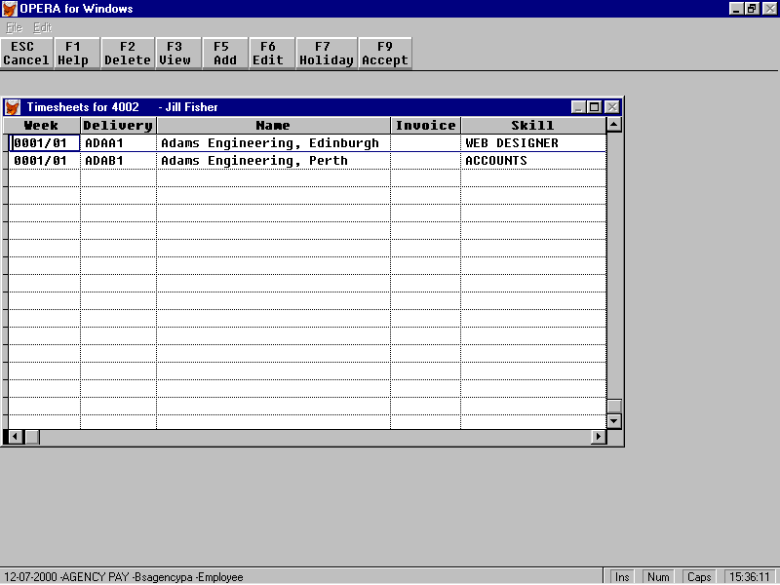

After adding or editing as required you may press F9 to make any changes permanent or you can press Esc. If you Esc, as a precaution, BS Agency Pay will ask if you want to abandon any changes so if the Esc key was pressed by mistake you can say No and the changes will be saved.

If the BS Agency Pay calculation has been done this week then this temp will be recalculated.

When processing a timesheet the first screen asks you to select (or change) the delivery account. The usual Opera facilities are available for finding an account.
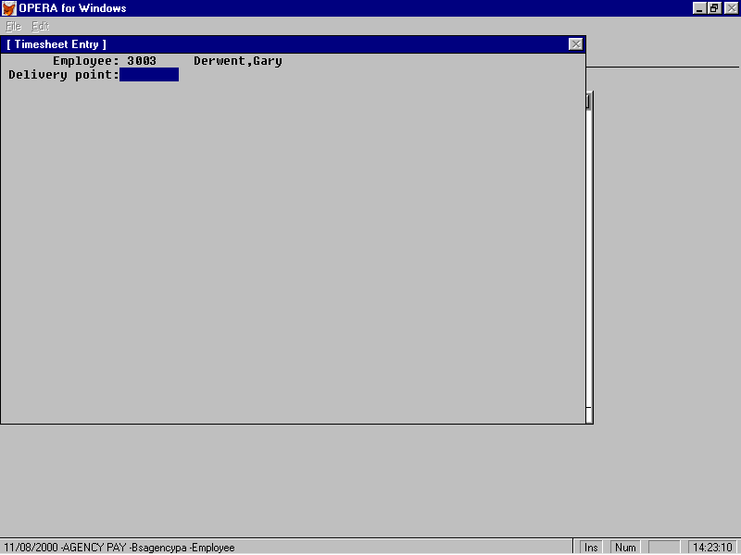

The next entry is the reference of the rate card to be used in extending this timesheet. (Page Up will return you to the previous screen.) The default from the delivery point will be displayed on a new timesheet. You may enter a blank - which means use the delivery point and employee’s rates or you can specify a rate card - which means use the rate card’s charge and pay rates. You will be allowed to enter any rate card which is not restricted to another delivery point or client.

If you leave this blank your time sheet will be extended at the rates you entered on the delivery point and employee. If you select a rate card, the timesheet will be extended at the rates on the time card for both charges and payments.

The next entry is the grade (skill) at which the work was done

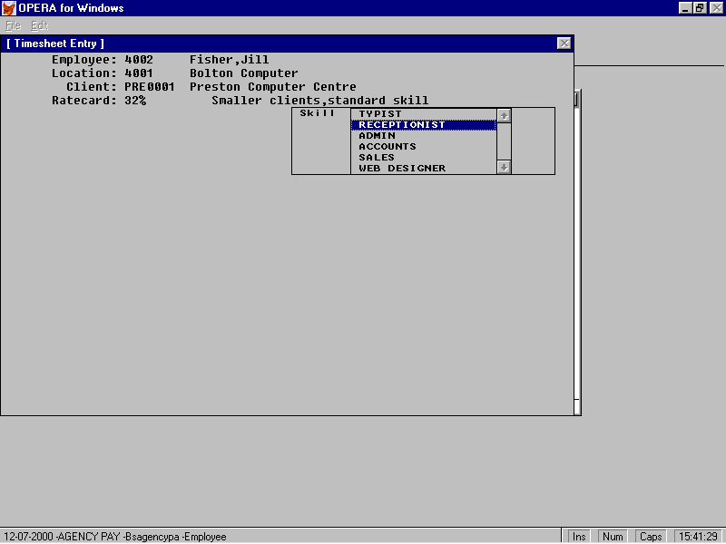
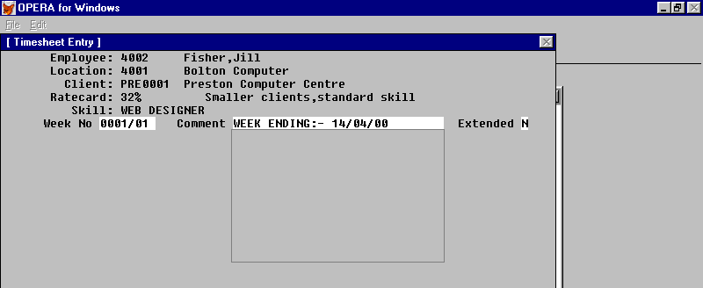

After selecting the grade you enter the week number and optionally a comment.

The week number is one character longer than the PAYE week to allow for two timesheets in the same (fortnightly) pay period – e.g. 9899/22A and 9899/22B.

When entering timesheets for employees in monthly paid groups (MBY) - the ‘week’ number is prompted with the current week number from group W.

Thus if you enter timesheets each week for an employee who is paid monthly, the (four or five) timesheets will have the appropriate week numbers. (N.B. margin reports relate to the week calculated so in, say, Month 8, which is processed as week 34, you might enter timesheets for weeks 31, 32, 33 and 34 but all will be calculated as week 34 and the month’s ERNI will be allocated to them.)

Timesheets for a monthly paid temp will not be calculated, paid or charged until the system reaches the appropriate week number. In say, week 4 AP will calculate all employees paid weekly and monthly; in weeks 5-7 only the weeklys and in week 8 the weekly and the monthlys. On the default rate card you can set the relationship between month numbers and week numbers.

The default value for the comment is held on the default rate card - typically it is “Week ending:” to which you append a date or you can put the date in each week. If you need more space you should enter Y in the extended box and you will then have space for considerable description of the timesheet.

The next section requires you to enter the hours to be paid at the various rates. Only those rates which have a charge rate for both the delivery point and a pay rate for the employee are available for entry (unless the rate specifically excludes payment or charge). You can also enter the timesheets reference number and you can specify that you must enter the number of working days that this timesheet represents.

You can enter a single figure for the week if you prefer - in the Monday column - and tailor your invoice print design to suit. (Remember you may specify on a rate card the number of columns and headings you want - the initial setting is 7 with Monday -Sunday but you might specify 1 column with ‘Week’ or 3 columns with “Day Night Back”.

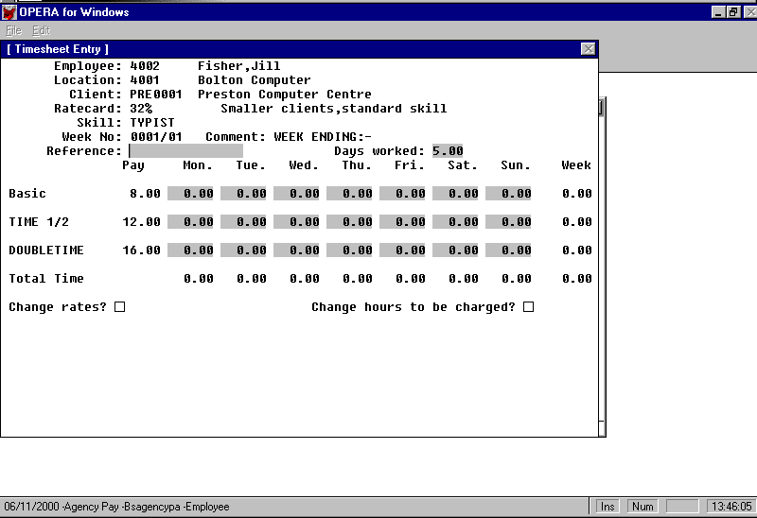
The skill and rates are shown to assist in selecting the correct row in case you have used descriptions such as Rate1, Rate2, Rate3 to allow more flexible rates. When you complete the entries the rate totals are shown for you to check against the employee’s totalling.

If the rate card permits, you can select to change both charge and/or pay rates; you can also change the hours to be charged. If you don’t use this option or don’t
When you complete this set of entries the next set is for mileage and expenses:-

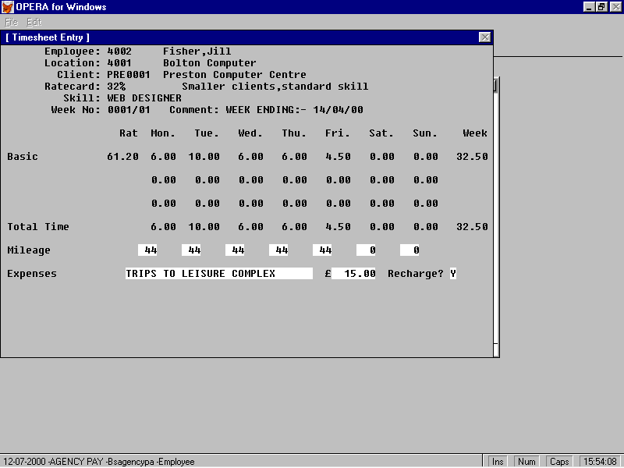

You should enter any mileage to be paid to the employee and/or charged to the client. If any expenses are to be included on the payslip/invoice a brief description should be entered and the amount.

In the BS Agency Pay menu you will find an entry for New Timesheets. This allows rapid entry of timesheets by avoiding the Find/next/previous options and the list of previous timesheets. You simply enter the employee’s reference and then immediately the timesheet details as above. If the entry is a duplicate of an existing timesheet it is rejected and you can if necessary use the Processing-Find-Timesheet route to resolve the problem.

3.13. Timesheet - Holiday Pay

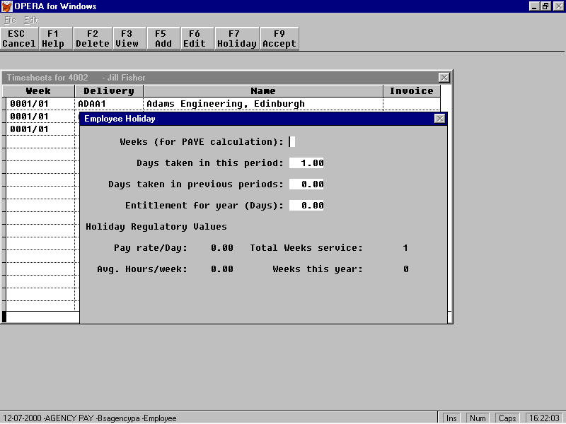

BS Agency Pay shows you the average rate, which it has been working out since the employee started, and the total annual holiday the employee is entitled to. You should enter the holiday being given to the employee this week, expressed in standard units as if the employee always worked your standard week - e.g. one day’s holiday or 7.5 hours holiday (or 10 days or 75 hours). BS Agency Pay will then scale this amount in line with the employee’s average working week.

In general you should not modify the entitlement or the hours taken in previous weeks as BS Agency Pay will maintain these automatically and will recalculate the entitlement every time it does a gross pay calculation.

Weeks (for PAYE calculation)

If this is left blank (or 0) the holiday is presumed to have been taken last week. If you enter 1(2 or 3) the holiday will be presumed to be taken next week (or more). In any case BS Agency Pay will post dummy timesheets as a record of holidays taken for use in calculating holiday entitlement and rates if the option require them.

3.13. Timesheets

This option allows you to enter timesheets without using the Opera methods of processing – find – timesheets etc. You can set your default choice of entry point to suit your working methods – the default is by rate card.

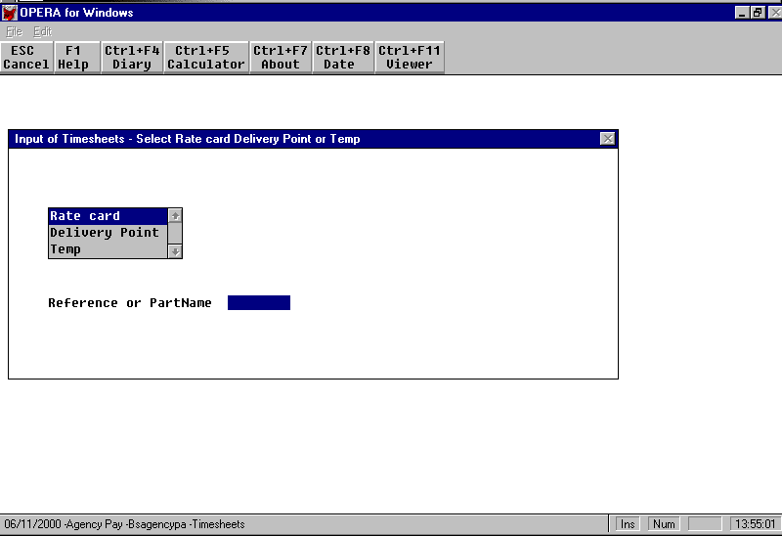
Selecting ‘Delivery point’ or ‘Temp’ is equivalent to using ‘Processing…Timesheets’. Selecting ‘Rate card’ allows you to select any rate card which has been restricted to both a single delivery point and a single temp. These references are then filled in automatically. If the rate card has only one skill, that is filled in automatically.

With this facility you might choose the following strategy:-

When a contract is agreed for a temp to do work at a delivery point:-

- Create a delivery point for that contract with the contract number as the reference.
- Create the temp record if not already in existence
- Create a rate card with the contract number as its refernce and restrict it to the delivery point and the temp.
- Enter timesheets by rate card, enter the contract number

3.14. BS Agency Pay – Bank Holidays

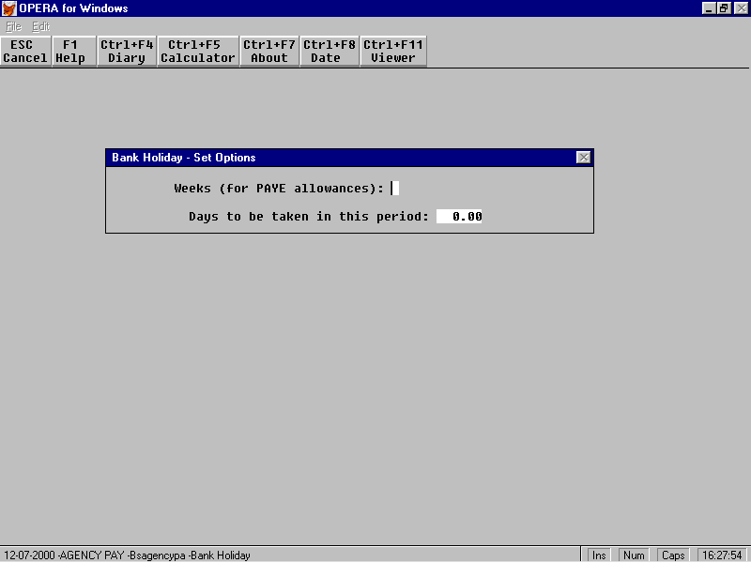

In this screen you may enter a holiday which applies to all employees. If there are exceptions you can remove the allocated holiday from them individually via the timesheet entry screen (F7).

The normal use of this screen is when a bank holiday occurred in the previous week and all employees are to have one day’s holiday.

Unusually, you can enter an extra week of tax allowances to be given. This will only apply if the whole payroll is on holiday for a week.

The holiday should be entered as standard units - e.g. one day or 7.5 hours. BS Agency Pay will scale this to correspond to each employee’s average hours. If your standard hours are set in utilities to 37.5 and the standard holiday is 7.5 hours then an employee who averages 22.5 hours per week over the last 12 weeks will receive 4.6 hours paid at his average hourly rate for the last 12 weeks.

3.15. BS Agency Pay - Calculate

The Calculate option on the main menu must be run at least once each week. There after BS Agency Pay will force a calculation of any individual who has had an amendment to his details, timesheet, holidays, etc.

Until the calculation has been run, most reports are inactive.

BS Agency Pay calculation has three parts

1. Calculate Gross pay from timesheets

2. Run standard Opera calculate of gross to net

3. Allocate ERNI

Stage 1 will move people from group to group - e.g. W to/from Z or A (and M to/from Y or B) as appropriate and for group W (or M) will calculate the gross pay from timesheets (this would have been done when the timesheet was entered but we do it again as a check and to incorporate any changes made to rate cards after the timesheet was entered)
During stage 1, BS Agency Pay also works out the employee’s average earnings and hours worked for the last 12 weeks (or as set in utilities) and puts these figures and the employee’s holiday entitlement into the appropriate records (creating a holiday payment record if necessary) for use when you grant holiday time. It also ensures that there is an accruals deduction record with the current accrual percentage present. (Creating one if necessary.)

Stage 2 is the standard Opera calculation of gross to net and E’er NI etc. You are invited to select groups to be calculated by Opera. This will be subject to your practice but should in general be A+W and B+M. You should also include groups Z+Y if your practice is to pay tax refunds to people with no timesheet.

You might choose to calculate gross to net for working temps (W+M) in BS Agency Pay calculate, then do the gross to net for non working temps (A, B [Y, Z]) in Opera calculate although there is no real reason for doing so.

Stage 3 applies only to groups W and M. The total of Employer’s N.I contributions is apportioned against the total pay for timesheets and the total pay for any other additions (e.g. holiday pay). The sub total for timesheet pay is then apportioned against the individual timesheets.

There are reports in both payroll and sales ledger to let you list the timesheets and check them before you finalise the payroll.

You should make any routine payroll changes/adjustments etc. as normal then calculate and print payslips. You may enter any such changes before the BS Agency Pay Calculate if you prefer.

Agency Pay has an interlock between its Calculate and its Update such that in any one week you will not be able to print payslips, invoices or margin reports or Update until after the Calculate has been done. After the Calculate has been done, any changes to timesheets will result in that temp’s timesheets being recalculated.

3.16. Invoice Printing

BS Agency Pay Reports and Sales Ledger Reports contain Client Invoices which will allow you to select some or all of your delivery points for invoicing. In the simplest case this means every week - invoice the W delivery points. For M (monthly?) delivery points you will have to work out a 4, 4, 5 week cycle and select these delivery points as appropriate. With a fortnightly (even and odd weeks) cycle as well you will be invoicing as follows:

Week:- | 1 | 2 | 3 | 4 | 5 | 6 | 7 | 8 | 9 | 10 | 11 | 12 | 13
Select | W | W | W | W | W | W | W | W | W | W | W | W | W
and |  |  |  | M |  |  |  | M |  |  |  |  | M
and | 1 |  | 1 |  | 1 |  | 1 |  | 1 |  | 1 |  | 1
and |  | 2 |  | 2 |  | 2 |  | 2 |  | 2 |  | 2

Delivery points for the same client need not all have the same frequency of invoicing e.g. charge out the cleaners weekly, the nurses fortnightly and the doctors monthly all to the same Health board, presumably with invoicing by delivery point not client.

You will be offered the chance to recalculate - this would normally be done if amendments have been made since the last BS Agency Pay Calculation was run. You then simply enter Y for the invoicing groups you want to print.

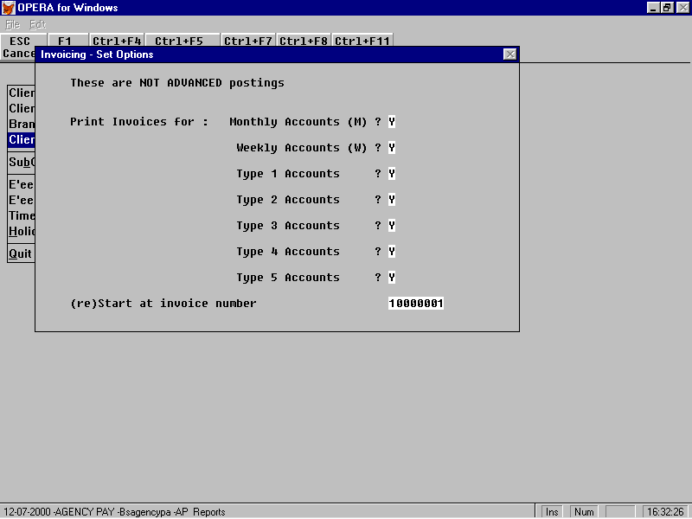

After the invoices have been printed you will be asked to select a print destination for the report produced by Opera’s import routine when posting the invoice data to the sales ledger. This will highlight any mis-postings. If the import routine rejects an invoice you should post it manually to the sales ledger. (Mis-postings will only arise if you unintentionally delete an essential sales code in Opera. The standard sales code program in Opera does not know if a code is currently required and will allow deletion. Deleting a sales code should be a rare thing anyway so we suggest that you don’t delete them - just change the name to “Do not Use”.)

If you are using multiple currencies (and EC VAT) you should have set up all relevant VAT codes – Home/ Non EC/ EC and registered there/ EC and not registered there. During invoice processing AP will search for each VAT code needed. If it cannot be found, a record will be created and you will receive a warning message that you should check it later. This also applies to Contractors Invoicing

3.17. Working Hours & Holiday Pay Enquiry

BS Agency Pay continuously calculates and records each employee’s entitlement to holiday pay and will process holiday payments automatically by simple entry of the holiday time taken.

You must enter all holiday figures in BS Agency Pay and ignore this option in Opera Payroll.

In addition there is an ad-hoc enquiry facility which allows you to produce a report of the employee’s payment history. This may be useful in the event of an investigation or as an aid to explaining to the employee his holiday entitlement.

In BS Agency Pay - Employee Processing there is a report, Averages, for employee’s to help you with the requirements of the working hours and holiday pay legislation (see section 3.18). When you have used the Find option to select the person you are interested in you may print a report which shows one line of data per calendar week. You can specify the starting week number. This will default to either 17 weeks ago or the employee start date, whichever is later.

The report shows cumulative totals and averages for:

- the entire period selected
- the last 17 weeks
- the last 13 weeks.

Additionally you can export the report data to various file formats such as Excel or Lotus which will allow you to calculate holiday entitlement etc.

BS Agency Pay recalculates the employee’s holiday pay entitlement every time you ask it to calculate gross pay from timesheets. The following paragraphs describe the simplest of the optional methods. The following pages go into more detail.

If the employee has worked for 12 weeks it records the average weekly pay, average hourly pay and average weekly hours worked during that period, it also counts the number of weeks which the employee has worked since the start of the holiday year.

From the number of weeks worked in this holiday year it calculates the employee’s entitlement. e.g. after 26 weeks out of 52 the employee will be entitled to half the year’s allowance - say 2 weeks out of 4.

In the set up you will have nominated that you wish to pay holidays by hours or days and your standard number of hours or days per week. Thus if your standard week is 37.50 hours the above employee is entitled to 75 hours of holiday. If your standard is 5 days a week then he is entitled to 10 days.

When he takes holidays you will enter the time taken - say 2 days - these will be paid at his average weekly rate - i.e. 2/5 of the average weekly pay over the last 12 weeks. Similarly 75 hours of holiday will be paid as two weeks at the average weekly rate.

Thus an employee who works longer hours will be entitled to the same amount of holiday days as an employee who works shorter hours but he will be paid for each day at a proportionately higher rate.

Working Time Regulations – Definitions and Options

These options are set on the 4th screen of the default rate card (see page 25)
Week Number

The number for a payroll week - the PAYE week number, e.g. 9899/52 or 0001/01 etc. BS Agency pay keeps a file of all week numbers entered, for use as a calendar. It should be noted that a week with no timesheet entered for any employee will not appear in the calendar and will not be counted. If this (rare?) event occurs it is possible to make an entry in the calendar by entering a timesheet and then deleting it.

Qualifying period

The number of weeks defined in the default rate card. (Current regulatory number is 13. We will use 13 in the notes below)

Qualifying earnings

The hours and pay for the first band (‘Basic’) plus optionally those for either or both of the overtime bands. (This is defined in the rate card) Holiday pay entered via BS Agency Pay is also a qualifying earning.

There is an option to enter a number of days on each time sheet – any such days will be assumed to be qualifying days (e.g. Monday to Friday). Associated with this option is a maximum per week (typically 5).

Employee Qualified for Holiday pay

An employee qualifies for holiday pay when he has completed a period of 13 consecutive weeks of employment (i.e. without being marked as a leaver). You can choose whether or not to allow any non worked weeks in this 13 week period to be accepted or not.

If you choose the option to say that the employee must have qualifying earnings in each of those weeks then a break of one or more weeks without qualifying earnings means that the qualifying process must restart. Thus qualifying earnings in weeks 1 to 11 but none in week 12 means that the earliest qualifying period will be weeks 13 to 24. Any break in weeks 13-24 means a further similar delay.

Averaging period

The number of weeks over which the employees qualifying earnings are to be averaged; this is set in the default rate card. (Current regulatory value is 12, we will use 12 in the following notes).

Annual Holiday Entitlement

This is a number of weeks times the number of days per week set in the default rate card (Current regulatory value is 4 times 5 = 20. We will use 4, 5 and 20 in the following notes. This may also be expressed as a number of weeks times a number of hours)

Holiday Year

The agency will define the period during which the annual holiday entitlement is available. This is set in the default rate card as a number of weeks and a start week number. (The number of weeks will usually be 52 but will need to be set to 53 every 7 years or so. We will use 52 in the following notes). This is the calendar year not the ‘working year’.

There is an option to include or exclude holidays taken into the calculations.

Employee’s Holiday Entitlement

This can be calculated in a number of ways:

Option 1

An employee who has qualified is entitled to that proportion of the annual holiday entitlement corresponding to his weeks worked in this holiday year over the number of weeks in this holiday year. Weeks with only holiday pay are counted and the entitlement is a proportion of 52 weeks. In a full year every employee will have 20 days holiday. Part time employees will have a lower rate per holiday-day than full timers.

Option 2

Each employee has a standard number of days per week and the entitlement is apportioned against the company standard week. Thus a ‘2 day a week’ employee will be entitled to 8 days a year (20 x 2 / 5)

Option 3

If employees work very variable weeks or you do not wish to use a standard number of days per week you can enter the number of working days for each timesheet. The employee’s cumulative day’s worked are then calculated and his entitlement is based on that number as a proportion of the standard year. E.g. after working 13 days the employee is entitled to 20 x13/(52 x 5) = 1 days

Employee’s Holiday Pay Rate

The employee’s holiday pay rate is calculated by totalling his qualifying earnings over the averaging period. The total time worked is then calculated. The method of calculation depends on the option chosen for calculating holiday entitlement.

Option 1

The employee is entitled to 20 days at appropriate rate irrespective of his average working week; for a part timer the rate per holiday day may be much less than a working day. The rate is calculated by dividing the earnings by the agency standard time – e.g. 12 weeks x 5days (or 12 x 37.50 hours).

Option 2

The employee is entitled to a number of days in proportion to his average working week; the rate will be similar to his working day rate. In this case the rate is calculated by dividing the earnings by the employee standard time – e.g. for a two day a week employee - 12 weeks x 2days. (or 12 x 15.00 hours)

Option 3

The employee is entitled to the number of days in proportion to the days he has worked; daily rate will be similar to his working rate. In this case the rate is calculated by dividing the earnings for the 12 weeks by the days worked in the 12 weeks. (e.g. 54 days or 399 hours)

Taxation of Holiday pay

You can pay for holidays in arrears (e.g. a bank holiday Monday taken last week) or in advance (e.g. summer fortnight to be taken next week etc) e.g. an employee working in week 34 is paid for the timesheet for work done in week 33 plus holidays to be taken in week 35 and 36. In week 37 he will be paid by inputting the timesheet for work done in week 34 (this could have been inputted in week 35 as long as it was dated for week 37).

Choosing a Holiday Qualification Option

The qualification option has two choices (set by L_FOREST[1])

Option 1

After 13 weeks without a P45 the employee has qualified for holiday pay. The number of weeks with a timesheet do not play any part in qualification.

If someone stops work during the 13 weeks you should make them a leaver.

If a leaver restarts then they are a new employee and must re-qualify by staying for 13 weeks

Option 2

The employee must have qualifying time in for 13 consecutive weeks. Any week without a timesheet breaks the sequence and resets the count. (You can give holiday time in this period and it will be counted as a ‘working’ week)

Choosing a Holiday Entitlement Option

The entitlement option has three choices (set by l_forest[2],l_fores[5]

Option 1

If your employees, in general, all work a full week of approximately the same duration then you can choose this option. You define your Agency Week as (say) 5 days or 37.50 hours. Every employee is then entitled to 20 days a year (or 150 hours) holiday in a full year. Their rate will relate to their earnings in the last 12 weeks. If someone works a 40 hour week then the rate for his 5 day holiday will be higher than someone who only works 35 hours (at the same hourly rate).

When entering timesheets you will enter the qualifying hours worked for the week. You don’t have to enter the number of days.

Option 2

If your employees work a variety of days per week – some are full time some are two days a week etc, but any one employee’s working day is fairly standard then you can use this option. You declare this person as a 2 day a week or 5 day a week worker (or a number of hours). This method keeps the holiday rate in line with the working rate but reduces the entitlement – a 1 day a week worker will get 4 days holiday, a 2 day a week worker gets 8 etc.

When entering timesheets you will enter the qualifying hours worked for the week. You don’t have to enter the number of days.

Option 3

If your employees work varying numbers of days or you don’t want to dictate a standard for days or hours/week you can use this option.

When entering timesheets you will enter the qualifying hours worked for the week and the number of days. If an employee has more than one timesheet in the week you will enter the number of days on each. The system will add them up and will restrict the total in the week to a limit which you set.

Choosing to include Holiday weeks (set by L_INCLHOL)

If you elect to include holidays then the formula for entitlement is (weeks worked + weeks holiday) / 52. At week 48 the entitlement will be less than 4 weeks (18.46 days and you would use the override facility to give the employee 4 weeks holiday)

If you do not include holiday weeks the formula is weeks worked / (52 - annual holiday weeks). At week 48 the entitlement will be 4 weeks.

Holidays – Entering Holiday’s taken or to be taken

The screen allows for two entries – the number of weeks of additional tax allowances to be given and the number of days holiday being paid for.

There are two obvious situations and the following examples should help to make them clear. In both cases we will take the current week to be week 30 so we are processing timesheets for work done during week 29. We assume that the temps work 5 day weeks and are entitled to the holidays.

Tom had a day off last week (week 29) and handed in a timesheet for the other four days

Enter the timesheet

Enter one days holiday with no extra weeks

Dick is going away for the next two weeks (31 and 32). He handed in a timesheet for a normal week (29)

Enter the timesheet

Enter 10 days holiday with 2 weeks additional tax allowances

Dick’s timesheet for the work done in week 30 should be held aside until he comes back in week 33.

Harry had day off in week 29 and is going on holiday for week 31

Enter his timesheet for 4 days in week 29

Enter 6 days holiday with 1 weeks additional tax

Hold over his timesheet for work done in week 30 until week 32

Payroll Update

After each week or month’s processing is complete you should carry out the period end procedures on all groups used by BS Agency Pay. (Weekly - WAZQ, Monthly - MBYR.) This must be done from within BS Agency Pay’s Utilities. You will be asked to select Weekly or Monthly (or both). You will then be asked (by Opera) the usual questions for updating each of the groups you selected.

During the update process, BS Agency Pay will add this period’s holidays to the to-date figures and zeroise this period.

During the update process BS Agency Pay will check if the new period number seems to be the start of a new holiday year. If so, and if you agree, the to-date figures will be zeroed. Agency pay will also add, to its calendar file, the new week number and the subsequent 4 weeks. (These are used when allocating holiday pay to future weeks). This will require you to answer questions like “Is there going to be a week 53 this year”

The BS Agency Pay calculation routine also checks that the week number being calculated is in the current holiday year and if not it asks you if you want to change the holiday year details.

In every BS Agency Pay calculate, any employee known to BS Agency Pay but who has been deleted from payroll (typically following PAYE year end) will be deleted from BS Agency Pay. BS Agency Pay will ask for permission to pack its files if it finds any records flagged for deletion. You should say Yes but after the pack operation the deleted records cannot be recovered.

You should try to update monthly groups just before the corresponding weekly update (.e.g. at the end of week 5 – update month1 then week 5).

AP History

When a new system starts, there is a need to enter records of hours and earning for the preceding weeks (12 for holiday pay / 17 for minimum pay)

This option proceeds in three phases – as follows

- If you have a CSV or DBF file of history it will be absorbed into the history work file. The details of these files are shown below. If you have no such file you can enter all history at phase 2.
- You may browse and add / edit / delete the records in it.
- The records in the work file are added to the main timesheet file, provided they have valid references and are unique . Any rejected records are retained in the work file. The next run of this program may add more imported records and will allow you to correct or delete any records rejected on this run.

The CSV or DBF file should have 4 fields as shown in this dbf structure:

Ts_ref Char 8 left justified employee reference
Ts_week Char 8 week number e.g. 9798/01 or 0001/12A
Ts_avgehrs Num 10,2 hours for this timesheet
Ts_avgepay Num 10,2 pay for this timesheet

e.g. for CSV

“091”, ”0001/15”, 37.5, 750.0
“091”, “0001/15A”,10,300
“091”,”0001/16”,37.5,750
etc

Be careful that products like Excel do not convert references or week numbers into numerics.

AP Reports
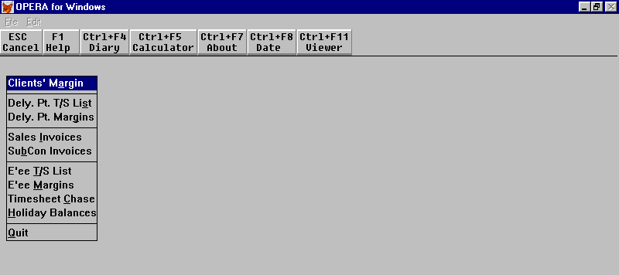

Clients Margin

This report shows the actual hours worked, the amount paid to the employees, the employers national insurance total, holiday accruals, the amount charged to the customer and the margin as both value and percentage. There is also a line on the report showing the averages. If cost centres exist in the Nominal Ledger this report will group each Client by Cost Centre. Totalling is by Client.

Dely. Pt. T/S List

This report lists all timesheets, that have not yet been invoiced, for the Delivery Points specified when the report is run.

It details the employee, timesheet number, delivery point, week number, rate card and skill. It shows the hours worked per day, the rate per hour, the payment and the total pay due. It also details any mileage or expenses. Grand Totals are given at the bottom of the report.

Dely. Pt. Margins

This report holds the same information as the Clients Margin report (detailed above) but is run for Delivery Points rather than Clients. Again if Cost Centres exist in the Nominal Ledger the report will group each Delivery Point by Cost Centre. Totalling for this report is by Delivery Point.

Sales Invoices

When this report is first selected you are asked whether you want to run a calculate and whether they are advanced postings. This report then produces invoices for timesheets posted against delivery points and updates the Sales Ledger accounts as appropriate. (see section 3.16)

SubCon Invoices

This report produces invoices for Sub Contractors in the same way as the Sales Invoices report with the Purchase Ledger being updated.

E’ee T/S List

This report lists all timesheets for employees whose timesheets have not yet been invoiced.

It details the employee, timesheet number, delivery point, week number, rate card and skill. It shows the hours worked per day, the rate per hour, the payment and the total pay due. It also details any mileage or expenses. Grand Totals are given at the bottom of the report.

E’ee Margins

This report shows the actual hours worked, the amount paid to the employees, the employers national insurance total, holiday accruals, the amount charged to the customer and the margin as both value and percentage. There is also a line on the report showing the averages.

If Cost Centres exist in the Nominal Ledger this report will group each Employee by Cost Centre.

Timesheet Chase

This report lists all employees who have not handed in a timesheet for the week specified when the report is run.

Holiday Balances

This report is broken down by department. It details each employee, their holiday entitlement to-date this period, any holiday’s taken to-date this period and any planned holidays for this period, their holiday entitlement balance in days, their holiday rate per day and the balance of this. Totals are given for each department and for the company as a whole.

When running the report you are given the option to include/exclude leavers and for employees with zero entitlement.

4. Training and Customisation

4.1. BS Agency Pay - Demonstration data

We have created a small demonstration set - it is in Company G and is published as ap3data.zip

For effective demonstrations -

- create (or rename) a portrait laser printer with ‘JET’ in its name - use it to print invoices and payslips.
- create a folder in opera\data for Company G e.g. opera\data\companyg
- create company G in Opera using this folder(Sales to N/L)
- create a user G - preferred company G, preferred printer Jet;
menu System. Sales, Purchase, Nominal, Payroll, BS Agency Pay
- pkunzip a:ap3data in the folder for company G

Start by printing the sales and payroll margin reports to see which customers and employees are already active.

Then look around as follows

- in employee or contractor processing look at the timesheets already entered
- add new timesheets in employee, contractor or new timesheets
- in rate cards - look at the rate cards
- run (BS Agency Pay) calculate
- in payroll - reports - print payslips
- in reports - print lists and margin reports
- in reports - print SubCon invoices
- in reports - print Sales Invoices
- in employee - print an averages report
- Period end all groups

4.2 Customisation

All reports are created via the standard Opera process and may be edited in the standard Opera way.

Menus are created via the standard Opera process and may be customised in the standard Opera way.

Some options are regarded as ‘sticky’ – i.e unlikely to change once the system has been set up. These are held in a separate file called BSGLOAD which is located in the system directory. These values are loaded when Opera starts.

They may be changed in Utilties – Version or with FoxPro or with Bsbrowse
(no alias, at command line: use system\bsgload, set order to 1, Esc, browse).

BSGLOAD has four columns

- ARG C 12
The name of a variable or array (conventionally always :=L_*; if not :=* they will be ignored)
- SEQ C 4
blank if the line is a variable; a sequence number if this is an array
- RESULT1 C 60
the value to be loaded into this variable or array element
- DESCRIP C 35
a description of this line

Your system is supplied with a file bsgstart which will be included in each subsequent issue. On each Opera start up the following process is observed

If bsgload does not exist – create it.

If any entry in bsgstart does not exist in bsgload create it

Create global variables or arrays from the entries in bsgload

This allows you to maintain the entries in bsgload which will not be overwritten by subsequent issues. Any future new entries in bsgstart will be added to your bsgload.
The entries most likely to need altering are as follows (initial settings shown bold):

L_inclhol .t. – holiday weeks are counted as working weeks (use 52 weeks in year)
.f. – holiday weeks don’t count – use 48 weeks in year.

L_forest[1] .f. – holiday qualifying period can include non working weeks
.t. – must have 13 consecutive weeks with qualifying time.
L_forest[2] .f. – use default rate card number of days in week as standard when calculating holiday entitlement.
.t. – use each employees standard days worked
L_forest[5] .f. – use standard days in week when calculating holiday entitlement.
.t. – get days worked at entry of timesheet
l_forest[6] 5 – the maximum number of days permitted on a timesheet or in total from the timesheets for a week.

In Utilities-Version you will find facilities to print the current settings file and to edit it.

NB – You must get the syntax in the entries in BSGLOAD exactly right or your system may not start. Always make a copy of bsgload.* before altering it.

4.3. Invoice and Payslip Design

Each timesheet on an invoice or payslip is printed from a memo field on that timesheet or payroll record. These memos are prepared during BS Agency Pay’s Calculate routine. The routine creates an array with all the relevant hours, rates, extensions etc. and then uses sets of parameters to create the memos. This allows a choice of sales invoicing designs and customised payslips and contractor invoices.

The array is called atotals and is 8 rows by 17 columns

The array relates to 8 sections of a group of timesheets for one employee

Row 1 provides header data for each timesheet
Rows 2-4 provides the data for each of the three bands of hourly rates
Row 5 is the mileage
Row 6 is the expenses
Row 7 the footer for each timesheet
Row 8 the footer for all timesheets for this employee

Columns 10+11 are the charge values, columns 12+13 are the pay values for hours. 14+15 and 16+17 are charge+pay for mileage & expenses respectively

 | 1 | 2 | 3 | 4 | 5 | 6 | 7 | 8 | 9 | 10(ch) | 11(ch) | 12(py) | 13(py) | 14(ch) | 15(py) | 16(ch) | 17(py)
1 | T/sht no | Temp no | PayeeName | Week no | Skill | Comment | NI No | Clt A/c | Clt name | Delac | DelNm
2 | “standard” | Mon hrs | tue hrs | wed hrs | thu hrs | fri hrs | sat hrs | sun hrs | week hrs | rate | value | rate | value
3 | “time+1/2” | Mon hrs | tue hrs | wed hrs | thu hrs | fri hrs | sat hrs | sun hrs | week hrs | rate | value | rate | value
4 | “double” | Mon hrs | tue hrs | wed hrs | thu hrs | fri hrs | sat hrs | sun hrs | week hrs | rate | value | rate | value
5 | “Mileage” | Mon mls | tue mls | wed mls | thu mls | fri mls | sat mls | sun mls | week mls | rate | value | rate |  | value | value
6 | “Expenses | Text |  |  |  |  |  |  |  |  | value |  |  |  |  | value | value
7 | “Totals” | Week hrs | week hrs | week hrs | week hrs | week hrs | week hrs | week hrs | week hrs |  | value |  | value | value | value | value | value
8 | “Totals” | Week hrs | week hrs | week hrs | week hrs | week hrs | week hrs | week hrs | week hrs |  | value |  | value | value | value | value | value

thus atotals[1,1] is the timesheet number and atotals[7,11] is the total charge value. The hours, miles, rates and values are all numeric, the rest are character.
From the array, the timesheet description memos are constructed using the rules you set up. If you do nothing, the default rules will prevail.

In each rate card and the defaults there are six memo fields:

bsc_def1 and bsc_def2 define the two invoice layouts
bsc_def3 is the header for the payslip
bsc_def4 is the individual timesheet on the payslip
bsc_def5 is the footer for the payslip
bsc_def6 defines the timesheets on the self billing invoice.

You can modify these memo fields within BSbrowse or with FoxPro

In System - Utilities - BSbrowse - alias BSCARD, order = 1, shared = Y

browse BSCARD and select the rate card to modify (usually the default)

Esc and take command line

at dot prompt type - modi memo bsc_defN

make changes

Ctrl+W to write,Ctrl+Q or Esc to quit

Esc Esc Esc

Here is example of bsc_defN with a comments column which is not present in the memo.

NB some lines are at the left margin and some are indented.

1atotalsl[1,1] |  |  | L. margin - new line in output
 | ” Refce:”+atotals[1,2] |  | indented another column on this line
 | “ Name”+atotals[1,3] |  | indented another column on this line
1repl(“-”,82) |  |  | L.margin - new line in output
 |  |  | above defines a header of two print lines
2atotals[2,1] |  |  | L margin - new line in output
 | str(atotals[2,2],6,2) |  | indented - another column
 | bwci(atotals[2,3],6,2,2)
 | bwci(atotals[2,4],6,2,3) |  | lines from section2 will be printed only if there
 | bwci(atotals[2,5],6,2,4) |  | are hours for basic pay
 | bwci(atotals[2,6],6,2,5)
 | bwci(atotals[2,7],6,2,6) |  | see below for functions bwci and bwz
 | bwci(atotals[2,8],6,2,7)
 | str(atotals[2,9],6,2)
 | str(atotals[2,10],6,2)
 | str(atotals[2,11],8,2) |  | (value for basic hours)
3atotals[3,1] |  |  | L margin - a new line in output
 | etc |  | line(s) for section3 will be printed only if there
 |  |  | are hours for section3
4.... |  |  | lines for sections 4,5 and 6 will be printed only if
 |  |  | there are hours for these sections
5....
6....
7repl(“-”,82) |  |  | section 7 is always printed if you specify lines
7padr(“Totals”,15) |  |  |  | i.e. if there are no lines for section7 then no
 | str(atotal[7,2],6.2) |  | footer will be printed
 | etc
7repl(“=”,82) |  |  | this shows a 3 line footer

Thus - if you want to print a line for one of the 7 sections you must start with a left justified phrase consisting of the section number and a FoxPro expression. On subsequent lines of your definition you put the continuations of the line as indented expressions (one or more spaces). To print a second or subsequent line for that section you start again with a left justified phrase with the same section number. The groups of lines for each section must be in ascending order of section number.

You are not restricted to using the array - any valid FoxPro function, field or variable may be used. Each expression must evaluate to a character string. You need to put in spaces etc. to line up columns etc. The initial settings used by BS Agency Pay when a new company is created are in system\bscard.dbf

We provide additional functions:

BWZ(expn1,expn2,expn3) - as str(...) but Blank When Zero

BWCI(expn1,expn2,expn3,expn4) - as str(...) + expn4 = column number
but Blank When zero if Column Inactive
(i.e. if this rate card only allows 4 columns then columns 2 and 3 will print 0.00 but 4-7 will be blank NB this column is not the column of the array printed above)

BSMEMO(expc,expn1,expn2) to print expanded comments/memo
expc - memo; expn1 - left margin width; expn2 - memo width

e.g.
1space(55)+atotals[1,06]
1bsmemo(atsht[70],55,30)
will print the extended comment under the standard comment in columns 56-85.

N.B. bsmemo should normally be used on a line by itself as above - if bsmemo is used anywhere except as the first and only field on a line it will return only the first line with no leading margin

Within any definition - a section whose lines begin with 1 will always be printed. Sections 2-6 will only be printed if there is some value for basic pay, overtime1, overtime2, mileage and expenses respectively. Sections 7 and 8 are always printed. A defining memo can be left empty - e.g. bsc_def3 if you don’t want a header on the payslip header

4.4 BS Agency Pay - Import System

AP can import Clients, Employees and Timesheets. The input format is currently that of Tempaid. AP will fill the gaps in the Tempaid data. The translation of Tempaid data to AP data is via a set of rules which may be customised. The settings which are issued with BS Agency Pay are based on a small sample of Tempaid data which did not match the Tempaid documentation. You may well need a degree of trial and error required to establish a reliable working export/import system.

Conversion of Imported files to dbf

- Tempaid files are of type SDF (text lines with cr+lf). Each field is defined by its length and the order in which they occur. AP requires the field lengths in order.
- BSGSTART delivers three tables of field lengths (:=l_snimport, :=l_wnimport, :=l_tsimport). These are in the settings file where they may be customised if necessary using Utilities – Version or Bsbrowse (command line – use system\bsgload excl).

Translation of Tempaid fields to opera fields

- ?_BSXREF contains rules for creating required Opera data from Tempaid fields. BSXREF may be studied and maintained from BSBrowse (alias BSXREF, order 1 shared No)
- As issued there are three parameter sets, each of which contains the rules for one type of data. The type of data is identified by the presence of a keyword (Client, Employee, Timesheet) in the first column (bssupp). There may be more than one parameter set for a given type and at run time the user will choose the appropriate set.
- Each parameter set contains the name (and path if necessary) to the data to be imported and the type (for Tempaid - SDF). As issued this is assumed to be in the root directory for opera and the file names are RECFPCLNT.DAT, RECFPEMP.DAT and RECFPTIM.DAT). All file and folder names should adhere to DOS conventions.
- Each parameter set has a control field (bsxselect) containing a Foxpro expression which must be true for a line to be processed. This gives the facility to exclude unwanted lines (e.g. ignore lines with no account number supplied) The issued value is .t. which means attempt to process all input
- There are then a large number of fields (F01,F02….) for rules (more columns can easily be added). Each rule contains the name of an Opera field, a comma and a Foxpro expression creating the data. This is typically based on an input field.
- The input fields are in an array whose entries correspond in sequence to the fields in the Tempaid data as defined in BSGLOAD. IN[1] is the first Tempaid field, IN[2] is the second etc.
- Since one Tempaid line may require the creation of more than one Opera record, the names of the Opera fields have been slightly enhanced (see BSXREF for examples)
Clients – use the Opera field name from SNAME preceded by either D(elivery Point), I(nvoice account) or S(tatement Account)
Employees – use the field names from WNAME preceded by E(mployee)
Timesheets – use the names from BSTSHT preceded by T(imesheet) or BSCARD preceded by C(ard)
- The import assumes that all the rules are applied to every line. Thus to use the import to update an Opera record, all the required data must be present in the imported data – not just changed fields.

Data integrity

- Clients – AP will print a commentary of its actions. It will report the creation and updating of Delivery points, Statement Accounts and Invoice Accounts (or the rejection of any data). Each line of input data will be taken as a delivery point. If a delivery point is created (or amended) without a valid statement account, one will be created with the same account number as the delivery point plus “S”. e.g. Delivery point 12345 will have account 12345S. (This could allow the removal of all rules relating to Statement accounts since the import will substitute for them). AP has no requirement for and does not use invoice accounts so these could also be removed from the rules – AP will not create invoice accounts.. The rules for clients should include all required fields, supplying defaults where necessary (profiles, analysis etc)
- Employees - AP will print a commentary of its actions. It will report the creation and updating of Employees (Contractors are not catered for). It will be the user’s responsibility to arrange that leavers are transferred to new numbers prior to importing (this is to allow for front end systems which export .a candidate, who is restarting after leaving with a P45, with the same reference number.
- Timesheets - AP will print a commentary of its actions. It will report the creation and updating of timesheets and rate cards. For each timesheet AP will create a rate card, which will have the delivery point and employee references. The ratecard will have the booking number as its reference. Tempaid timesheets have two or more lines, a header plus one or more sets of hours and rate. AP timesheet will process only the first three rates. From the start and finish dates, AP will calculate the number of days worked. The PAYE week will be deduced from the week-ending date (plus an offset l_tsplus, intially 3 days) using BSWEEK as a reference. Thus if the week ending data is on Sunday, the offset(+3) will make the payday Wednesday and the week number will be chosen to include that Wednesday. The sales codes, rate descriptions and other options will be taken form the default rate card.

Accrual 47
Accrual, set up 15
adjustments 8, 15, 48
AP History 60
bands 22
Calculate 9
Calculate 19, 47
charge 12, 13, 26, 27, 33, 40, 42, 49
client 12, 13, 15, 22, 24, 27, 31, 32, 33, 40, 43, 49
clients 21, 24, 27
Clients 27
cost centres 21
Customisation 64
Default 15
Default$ 22
defaults 22, 24, 26, 31, 34
delivery address 28
delivery point 12, 13, 14, 15, 21, 24, 26, 28, 31, 32, 33, 34, 40, 42, 49
delivery points See Delivery Point
Demonstration Data 63
E’Er NI 21
employee 9, 12, 13, 17, 22, 26, 33, 36, 39, 40, 42
expenses 15, 37, 43
Expenses 21, 27
first invoice 22
Group A 8
Group B 8
Group M 8, 9
Group Q 8
Group R 8
Group W 8
Group Y 8, 9
Group Z 8
Groups 8, 9, 15
History 60
Holiday Accrual 15
Holiday Calculation 47
holiday entitlement 30, 38, 44, 51
holiday pay 15
Holiday Pay 51
Holidays, entry 39, 44
Import 70
invoice 17, 22, 24, 27, 28, 32, 43, 49, 50
Invoice Design 66
Invoice Printing 49
Invoices, Documents 7
invoicing frequency 28
leavers 15
manual payment 9
margin 19
margins 12
mileage 15, 36, 37, 43
Mileage 21
Nominal code 21
pay 12, 13, 15, 19, 21, 26, 37, 40, 41, 42
payrates 12, 13
Payroll Update 59
payslip 17
Payslip design 66
payslips 6, 9, 17, 19, 25, 48
Payslips 6
Payslips, Documents 6
ratecard 12, 13, 14, 22, 24, 26, 31, 33, 34, 36, 40
ratecards 12, 13, 19, 22, 31
Ratecards 11
rates 11, 12, 13, 14, 21, 22, 24, 26, 33, 34, 36, 40, 42
report formats 17
Reports 61
Sales Codes 15, 21
skill 12, 13, 40, 42
skills 12, 14
Supply Codes 17
tax refund 8, 9
timesheet 8, 9, 11, 12, 13, 15, 19, 24, 26, 32, 33, 39, 40, 43
Timesheets, entry 45
timesheets,multiple 43
update data structures 5
vat code 21
Weekly Procedure 19
Working Hours 51
WTR 51
WTR Definitions 53
WTR Options 53
Year end procedures 29

